CAN bridge / smart repeater

# What is it?

This is a bridge with two CAN ports: CAN1 and CAN2. The CAN bus packet received by CAN1 port will be immediately transmitted from CAN2 port, and vise versa. There are additional configurable functions to filter and modify the passing through data:

* + - * packet acceptance filter for every port based on CAN ID mask matching,
      * baudrate configuration for every port,
      * bitwise ID and data modification of the passing through packets (controlled by mask matching conditions)

Device specification:

|  |  |
| --- | --- |
| Parameter | Value |
| Power supply voltage | 5V-20V |
| Current consumption | 60mA at 5V input |
| CAN baudrate | up to 1Mbps (any non-standard baudrate supported) |
| CAN ID mask filters | 2 (1 for each CAN channel) |
| CAN data replacement patterns | 40 (only for CAN1) |
| Microcontroller | STM32F105R8T6 |
| CAN transceiver | SN65HVD232DR |
| PCB size | 48.26 mm x 20.85 mm (1.9 in x 0.82 in) |

Board connections:

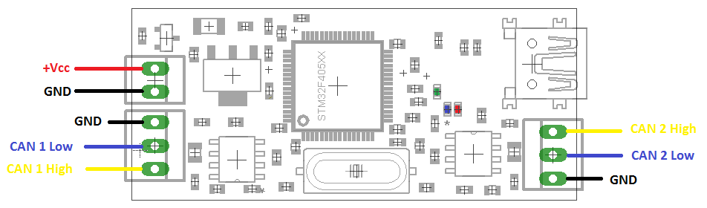

LEDs:

* Green: power on, also toggling every time when the CAN1 receiving and accepting message,
* Blue: toggling every time when the CAN2 receiving and accepting message,
* Red: constantly on if initialization failed or toggling after transmission fault.

# How to install and run software

* 1. Visit [www.st.com](http://www.st.com) and search for **STM32 Virtual COM Port Driver** in search box. Then download and install driver. You can try direct link [for 1.4.0 version](https://sites.google.com/site/akpc806a/en.stsw-stm32102.zip?attredirects=0&d=1) (This is a link to stored version at Goggle sites, so probably you should say "Yes" to download)
  2. Connect the CAN bridge using USB mini cable to computer. Make sure that the green LED is on the board and you have STMicroelectronics Virtual COM Port in Device Manager under COM ports

C:\Users\Alex\Pictures\User\COMport.PNG

* 1. [Download](https://sites.google.com/site/akpc806a/CANConfigureTool.zip?attredirects=0&d=1) and run **CAN Bridge Configuration Tool**. (This is a link to Goggle sites, so probably you should say "Yes" to download). Just unzip, no installation required.
  2. From the drop-down menu select COM port corresponding to CAN bridge and click *Open*.

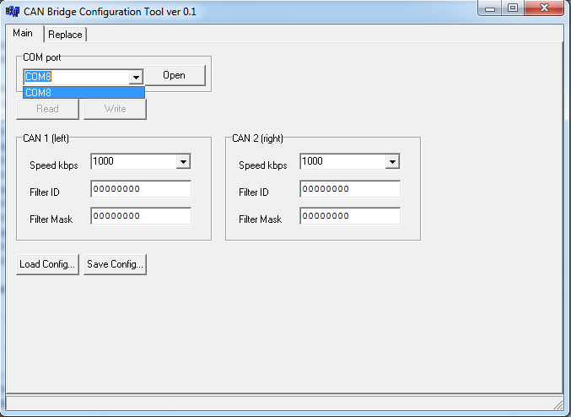

* 1. You can read parameters from the device by clicking *Read*
  2. You can write new settings by clicking *Write* button*.* **Warning**: **new settings will be applied only after power cycle of the device.**

If COM port is not listed in drop-down menu, try to reconnect USB device. If it doesn’t help, then check the driver installation. Try to download and install the latest driver. If COM port appears in Device Manager, it is possible to type manually the COM port name without using drop-down menu.

If *Read* button doesn’t work, i.e. its saying "Failed to send data" or "Failed to read data" check if the COM port you opened is really corresponds to the device.

# How to change baudrate

You can select from drop-down list desirable baudrate value separately for CAN 1 and CAN2, or you can enter any integer number.

Here is example of speed conversion. CAN1 is transmitting and receiving at 750 kbps and CAN2 is transmitting and receiving at 1000 kbps.

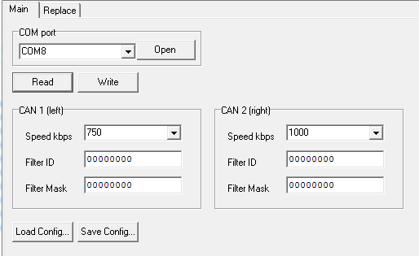

Here is oscilloscope waveform for stream downconversion from CAN1 to CAN2 corresponding to settings above:

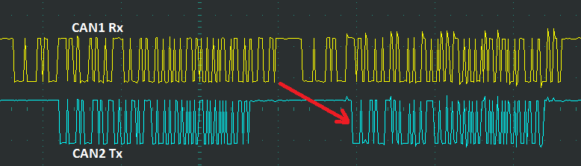

**Important notice**: because of lack of internal buffer be careful with baudrate downconversion. In this example make sure that the next packet is received at CAN2 after the previous one is started for transmission at CAN1.

# How to setup ID filter

The packet acceptance filter is controlled by two hexadecimal values:

1. Filter ID

C:\Users\Alex\Pictures\User\Filter_ID.png

Each bit specifies the level of the corresponding bit of the expected identifier:

**0:** Dominant (0) bit is expected

**1:** Recessive (1) bit is expected

1. Mask ID

C:\Users\Alex\Pictures\User\Filter_OD.PNG

Each bit specifies whether the bit of the received identifier must match with the corresponding bit of the expected identifier or not:

**0:** Don’t care, the bit is not used for the comparison

**1:** Must match, the bit of the incoming identifier must have the same level has specified in the corresponding identifier parameter filter (Filter ID).

As example considering following configuration for CAN 1

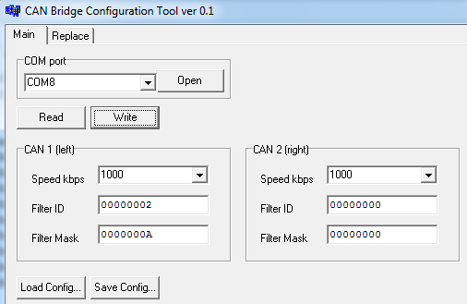

The Filter Mask is 0xA = 1010 binary and the Filter ID is 2 = 0010 binary. It means that the bit #1 and bit #3 of CAN identifier will be checked, and the bit #1 is expected to be 1 and bit #3 to be 0. Thus only identifiers with binary ending of …0X1X will be accepted by CAN1, i.e. in hex 0x?2, 0x?3, 0x?6, 0x?7.

Lets test this filter using CAN bus monitoring software.

Here is input stream of data at CAN1. This is basically 16 different CAN messages with identifiers from 0x0 to 0xF.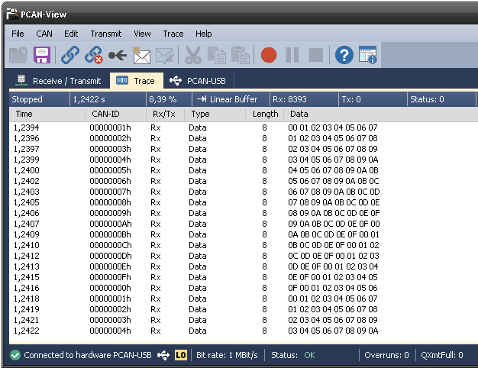

Here the messages passed through device and transmitted from CAN2: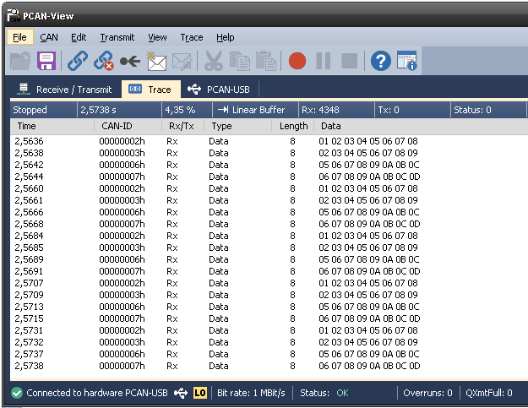

Basically only messages with identifiers 0x2, 0x3, 0x6, 0x7 are remaining in output stream.

# How to setup CAN data modification

It is possible to setup CAN data and ID modification patterns in the grid at page *Replace*.

Each replacement pattern is controlled by 4 hexadecimal values (for ID) and 4 arrays of hexadecimal numbers (for data):

1. ID Mask 

Each bit specifies whether the bit of the received identifier must match with the corresponding bit of the expected identifier or not:

**0:** Don’t care, the bit is not used for the checking of message acceptance by its ID

**1:** Must match, the bit of the incoming identifier must have the same level specified in the corresponding identifier filter parameter (ID Filter).

1. ID Filter 

Each bit specifies the level of the corresponding bit of the expected identifier:

**0:** Dominant (0) bit is expected

**1:** Recessive (1) bit is expected

1. New ID Mask 

If the message is being accepted for modification, each bit specifies if the corresponding bit of identifier will be replaced by value from New ID Value parameter:

**0:** This bit of identifier will be transmitted as in received message.

**1:** This bit will be replaced by corresponding bit from the New ID Value parameter

1. New ID Value 

Each bit specifies the new value of CAN identifier if the message is accepted for modification and the same bit in New ID Mask is equal to 1.

1. Data Mask 

This is 8 byte array specifies the acceptance of CAN message for modification by particular data contents. The bytes are separated by space. The byte corresponding to first byte of CAN data (data[0]) is the most left here. It has the same meaning as ID Mask parameter but for CAN data.

**0:** Don’t care, the bit in data byte is not used for the checking of message acceptance by data contents

**1:** Must match, the bit of the incoming data byte must have the same level specified in the corresponding bit and byte in parameter Data Filter.

1. Data Filter 

This is 8 byte array specifies the values of data bytes expected in CAN message accepted for modification.

**0:** If the same bit in Data Mask equals to 1, then this bit should be 0 in the received data byte for message acceptance

**1:** If the same bit in Data Mask equals to 1, then this bit should be 1 in the received data byte for message acceptance

1. New Data Mask 

If the message is being accepted for modification, each bit specifies if the corresponding bit of data will be replaced by value from New Data Value parameter. This is 8 byte array, the first byte of CAN data (data[0]) is the most left here.

**0:** This bit of corresponding data byte will be transmitted as in received message without modification.

**1:** This bit will be replaced in message data by corresponding bit from the New Data Value parameter

1. New Data Value 

If the message is being accepted for modification, each bit specifies the new value of the bit in corresponding data byte.

Please note:

* The CAN message will be accepted for modification if both ID and data are passed their filters.
* If the message has length less than 8 bytes, leave the last bytes by 0 for Data Mask and New Data Mask.
* Arrays are treated as numbers, for example single 0 will be considered as 00 for all bytes. Also it is possible to use any number of spaces to delimit the bytes.
* After programming the new configuration setup to device it is recommended to read back the configuration and check if the formatting of arrays.

We will demonstrate the usage of the replacement patterns by two examples: separately for ID modification and for data modification.

## CAN ID modification example

Let’s consider following entry at Replace table:

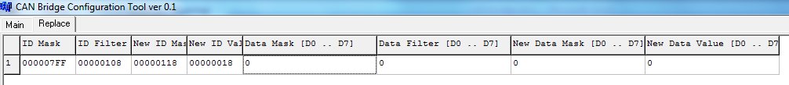

Here is:

ID Mask = 0x7FF

ID filter = 0x108

New ID Mask = 0x118

New ID Value = 0x018

It means that all first 11 bits of ID will be checked and only messages with identifier equal to 0x?108 will accepted for modification. Then the bits #3, #4 and #8 will be modified, because 0x118=100011000 binary. And the new ID is obvious from following:

100001000 – is only accepted ID,

100011000 – are modified bits,

000011000 – are new bits,

**000011000** – is new ID.

(Basically the bit #3 was not changed, it should be the same results with New ID Mask = 0x110

New ID Value = 0x010)

All parameters for data all 0, it means we are accepting any data content and don’t touch the data bytes.

Lets test this replacement pattern using CAN bus monitoring software.

Here is input stream of data captured at CAN1 port. The ID to be modified is highlighted by green color.

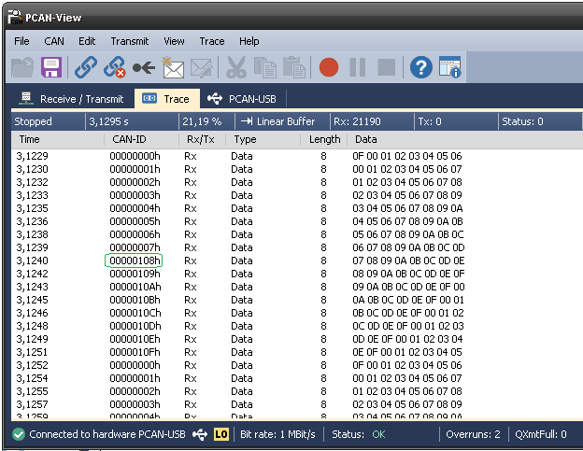

And here is data passed through device to CAN2 port. As results the identifier 0x108 changed to 0x18 in CAN data stream: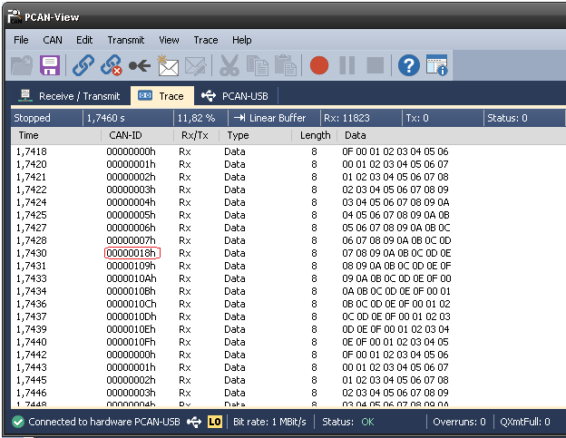

## CAN data modification example

Let’s consider another one entry in Replace table

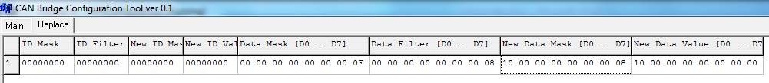

Data Mask = 00 00 00 00 00 00 00 0F

Data Filter = 00 00 00 00 00 00 00 08

New Data Mask = 10 00 00 00 00 00 00 08

New Data Value = 10 00 00 00 00 00 00 00

As result the only messages with byte #7 in form of 0x?8 will be accepted. And then bit #3 in this byte will be reset to zero. Also the bit #4 in first byte will be set to one.

Lets test this replacement pattern using CAN bus monitoring software.

Here is input stream of data capture at CAN1 port. The data bytes to be modified is highlighted by green color:

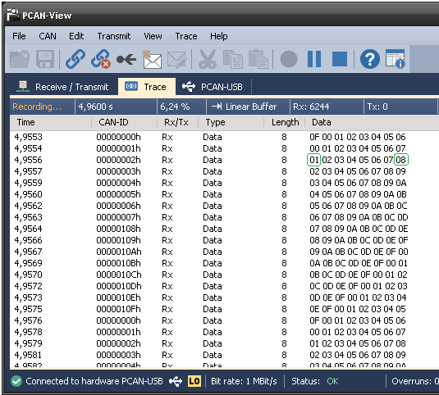

And here is data passed through device to CAN2 port. As results the identifier the first byte is changed from 0x01 to 0x11 and the last one byte is reset to 0.